**QMBU 450: Selected Topics in Quantitative Methods**

**Homework – 02 Report**

**Linear Regression**

**Name:** Abdul Rahman Hamadeh

**Brief Introduction:**

In this homework a linear regression function is implemented and is executed with collected data from an API.

The data is collected and is passed to a regression function that would fit a linear regression function into the data. The data being the currency exchange rate of USD to TL over the course of the last 100 days from the day the data collection function is called.

The data was retrieved using an API called [forex-python](https://forex-python.readthedocs.io/en/latest/usage.html)

**Hypothesis:**

The relation between time and the rising TL exchange rate allowed to fit a linear regression function that would provide rough future prediction of the exchange prices of the TL according to a given date.

Although linear regression would provide somewhat unreliable predictions for the overall TL exchange prices but, it gives acceptable results for the period the data was extracted on since the exchange prices are following the same trend since almost a year.

**Graphs and figures:**

In the following graphs, the x-axis represents the day numbers instead of the dates since the dates would fit and remain readable.

Note: the numbers represent days from oldest to earliest, i.e., The day with number 100 refers to the earliest day.

**The data set:**

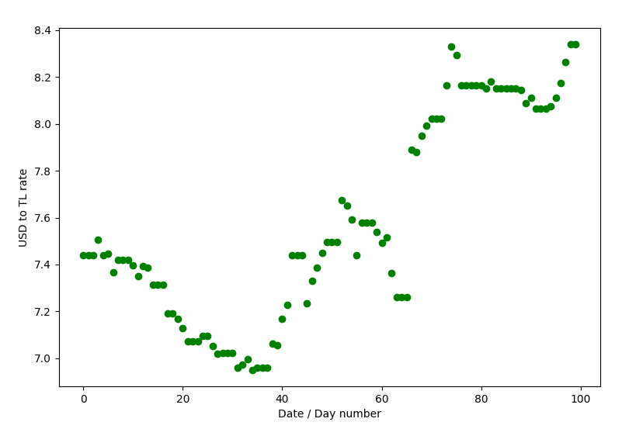

Figure 1: Data points

**With linear regression:**

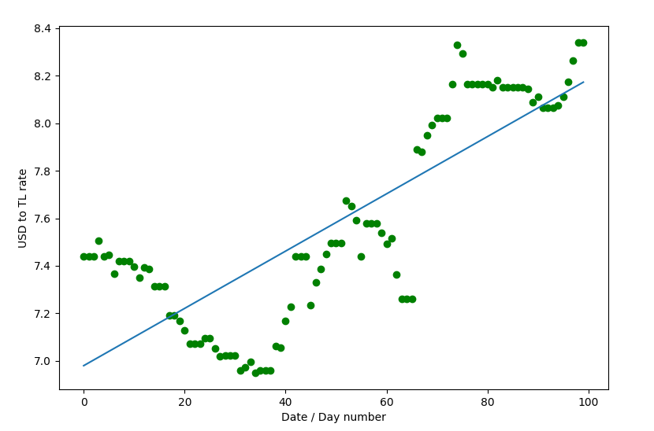

Figure 2: Regression line

**The credible intervals:**

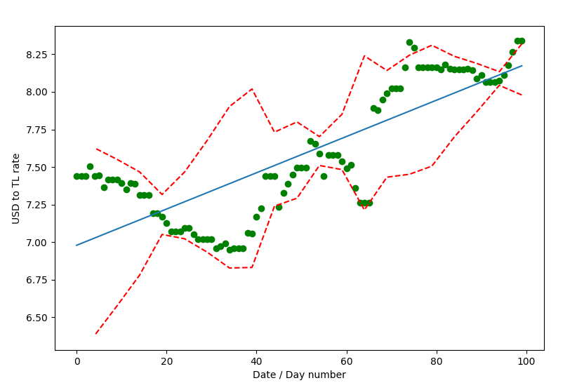

Figure 3: Credible Intervals

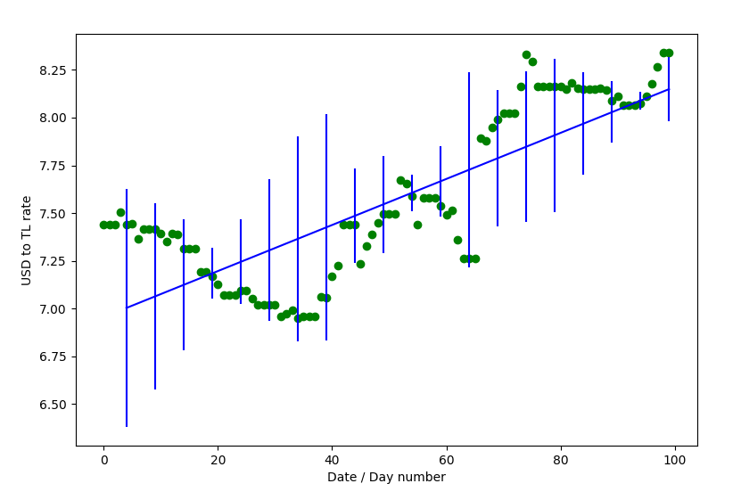

Figure 4: Credible Intervals 2